SOUTH DAKOTA BOARD OF REGENTS
ACADEMIC AFFAIRS FORMS

New Certificate

UNIVERSITY: | DSU
TITLE OF PROPOSED CERTIFICATE: | Quantum Computing for Cybersecurity
INTENDED DATE OF IMPLEMENTATION: | Fall2024
PROPOSED CIP CODE: | 11.0701
UNIVERSITY DEPARTMENT: | Beacom College of Computer and Cyber Sciences
BANNER DEPARTMENT CODE: | DCOC
UNIVERSITY DIVISION: | Computer Science
BANNER DIVISION CODE: | DSCI

☒Please check this box to confirm that:
- The individual preparing this request has read AAC Guideline 2.7, which pertains to new certificate requests, and that this request meets the requirements outlined in the guidelines.
- This request will not be posted to the university website for review of the Academic Affairs Committee until it is approved by the Executive Director and Chief Academic Officer.

University Approval
To the Board of Regents and the Executive Director: I certify that I have read this proposal, that I believe it to be accurate, and that it has been evaluated and approved as provided by university policy.
 |  | 1/10/2024
Institutional Approval Signature  President or Chief Academic Officer of the University |  | Date

Note: In the responses below, references to external sources, including data sources, should be documented with a footnote (including web addresses where applicable).

- Is this a graduate-level certificate or undergraduate-level certificate (place an “X” in the appropriate box)?
Undergraduate Certificate | ☐ | Graduate Certificate | ☒

- What is the nature/ purpose of the proposed certificate? Please include a brief (1-2 sentence) description of the academic field in this certificate.

This graduate certificate provides students with essential knowledge of quantum computing, its influence on cybersecurity, post-quantum cryptography, and quantum cryptography. Furthermore, it equips students with the knowledge and skills to analyze and create cryptographic solutions resilient against quantum attacks.

- If you do not have a major in this field, explain how the proposed certificate relates to your university mission and strategic plan, and to the current Board of Regents Strategic Plan 2014-2020.
Links to the applicable State statute, Board Policy, and the Board of Regents Strategic Plan are listed below for each campus.
BHSU: SDCL § 13-59 BOR Policy 1:10:4
DSU: SDCL § 13-59 BOR Policy 1:10:5
NSU: SDCL § 13-59 BOR Policy 1:10:6
SDSMT: SDCL § 13-60 BOR Policy 1:10:3
SDSU: SDCL § 13-58 BOR Policy 1:10:2
USD: SDCL § 13-57 BOR Policy 1:10:1
Board of Regents Strategic Plan 2014-2020

As the science behind quantum computing advances, DSU must include this field to achieve its mission to prepare cyber-savvy graduates. Quantum computing is the advancement of the special focus of DSU as a technologically focused university. This certificate specifically supports the DSU Strategic Plan, ADVANCE. It is directly related to Pillars 1 and 3, Increase Student Success and Grow Scholarship, Research, Intellectual Property, & Economic Development, respectively. This certificate will increase student success while also helping increase research and scholarship opportunities in the field of cybersecurity, which is a core element of DSU’s education.

- Provide a justification for the certificate program, including the potential benefits to students and potential workforce demand for those who graduate with the credential. For workforce related information, please provide data and examples. Data may include, but are not limited to the South Dakota Department of Labor, the US Bureau of Labor Statistics, Regental system dashboards, etc. Please cite any sources in a footnote.

The worldwide global quantum computing market was estimated to generate $866 million in revenue in 2023 and $4.375 billion by 2028. More industries are investing in and using quantum computing technology. To keep pace with other nations, the US needs to lean forward on this technology (see chart below). By offering this certificate, DSU is helping improve national workforce education and skills.
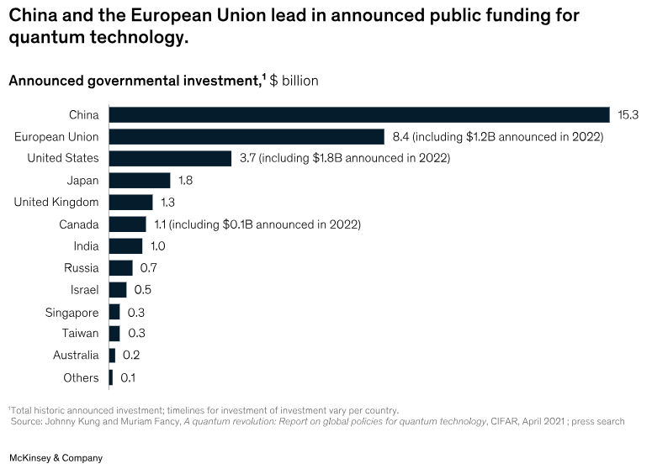
Thousands of universities, research organizations, and enterprises are already learning and experimenting with quantum computing. Given the amount of quantum computing investment, advancements, and activity, the industry is set for a dynamic change, similar to that caused by AI – increased performance, functionality, and intelligence. Quantum computing is where AI was in 2015, fascinating but not widely utilized. Fast forward just five years and AI is being integrated into almost every platform and application. In just five years, quantum computing could take computing and humanity to a new level of knowledge and understanding.

- Who is the intended audience for the certificate program (including but not limited to the majors/degree programs from which students are expected)?

Graduate students in the Beacom College of Computer and Cyber Sciences include master and PhD students in Artificial Intelligence, Computer Science, Cyber Defense, and Cyber Operations.

- Certificate Design
  - Is the certificate designed as a stand-alone education credential option for students not seeking additional credentials (i.e., a bachelor’s or master’s degree)? If so, what areas of high workforce demand or specialized body of knowledge will be addressed through this certificate?

This certificate is designed to complement existing master and Ph.D. programs.

  - Is the certificate a value added credential that supplements a student’s major field of study? If so, list the majors/programs from which students would most benefit from adding the certificate.

Yes.
Master: AI, Computer Science, Cyber Defense
PhD: Computer Science, Cyber Defense, Cyber Operations

  - Is the certificate a stackable credential with credits that apply to a higher-level credential (i.e., associate, bachelor’s, or master’s degree)? If so, indicate the program(s) to which the certificate stacks and the number of credits from the certificate that can be applied to the program.

No.

- List the courses required for completion of the certificate in the table below (if any new courses are proposed for the certificate, please attach the new course requests to this form). Certificate programs by design are limited in the number of credit hours required for completion. Certificate programs consist of nine (9) to twelve (12) credit hours, including prerequisite courses. In addition, certificates typically involve existing courses. If the curriculum consists of more than twelve (12) credit hours (including prerequisites) or includes new courses, please provide explanation and justification below.

Prefix | Number | Course Title  (add or delete rows as needed) | Prerequisites for Course  Include credits for prerequisites in subtotal below. | Credit Hours | New  (yes, no)
CSC | 763 | Quantum Computing Fundamentals | None | 3 | Yes
CSC | 766 | Quantum Programming | CSC763 | 3 | Yes
CSC | 767 | Quantum-Resilient Cryptography | CSC763 | 3 | Yes
CSC | 784 | Quantum Computing for Cybersecurity Applications | CSC766 or CSC767 | 3 | Yes
 |  |  | Subtotal | 12

- Student Outcome and Demonstration of Individual Achievement.
Board Policy 2:23 requires certificate programs to “have specifically defined student learning outcomes.

  - What specific knowledge and competencies, including technology competencies, will all students demonstrate before graduation? The knowledge and competencies should be specific to the program and not routinely expected of all university graduates.

Student Learning Outcomes. Students will demonstrate essential knowledge of quantum computing, its influence on cybersecurity, post-quantum cryptography to:

  - Develop a foundational knowledge of quantum computing, including its principles, algorithms, and applications to analyze and evaluate the potential impact of quantum computing on cybersecurity, including offensive and defense strategies.
2) Develop the skills necessary to design and analyze cryptographic solutions that are resilient to quantum attacks.
3) Gain a deep understanding of quantum cryptography, exploring its principles and applications for secure communication in the quantum era that develops into expertise in post-quantum cryptography necessary to explore the advanced cryptographic techniques designed to withstand quantum attacks.
4) Understand and adhere to ethical considerations of quantum computing to cybersecurity.

  - Complete the table below to list specific learning outcomes – knowledge and competencies – for courses in the proposed program in each row. Label each column heading with a course prefix and number. Indicate required courses with an asterisk (*). Indicate with an X in the corresponding table cell for any student outcomes that will be met by the courses included. All students should acquire the program knowledge and competencies regardless of the electives selected. Modify the table as necessary to provide the requested information for the proposed program.

Individual Student Outcome  (Same as in the text of the proposal) | *CSC 763 | *CSC 766 | *CSC 767 | *CSC 784
This course provides students with a fundamental understanding of key concepts, principles, and techniques in quantum computing | X
This course enables students to grasp and apply quantum algorithms, preparing them with the knowledge and skills necessary to write and understand quantum programs using the Qiskit framework |  | X
This course provides students with a comprehensive understanding of the challenges posed by quantum computers to classical cryptographic systems and to equip them with the knowledge and skills necessary to design and analyze cryptographic solutions that are resilient to quantum attacks |  |  | X
This course provides students with a deep and practical understanding of the intersection between quantum computing and cybersecurity |  |  |  | X

Modify the table as necessary to include all student outcomes. Outcomes in this table are to be the same ones identified in the text.

- Delivery Location.
Note: The accreditation requirements of the Higher Learning Commission (HLC) require Board approval for a university to offer programs off-campus and through distance delivery.

- Complete the following charts to indicate if the university seeks authorization to deliver the entire program on campus, at any off-campus location (e.g., USD Community College for Sioux Falls, Black Hills State University-Rapid City, Capital City Campus, etc.) or deliver the entire program through distance technology (e.g., as an on-line program)?

 | Yes/No | Intended Start Date
On campus | Yes | Fall 2024

 | Yes/No | If Yes, list location(s) | Intended Start Date
Off campus | No |  | Choose an item. Choose an item.

 | Yes/No | If Yes, identify delivery methods  Delivery methods are defined in AAC Guideline 5.5. | Intended Start Date
Distance Delivery (online/other distance delivery methods) | Yes | 015 Internet Asynchronous – Term Based Instruction | Fall 2024
Does another BOR institution already have authorization to offer the program online? | No | If yes, identify institutions:

- Complete the following chart to indicate if the university seeks authorization to deliver more than 50% but less than 100% of the certificate through distance learning (e.g., as an on-line program)? This question responds to HLC definitions for distance delivery.

 | Yes/No | If Yes, identify delivery methods | Intended Start Date
Distance Delivery (online/other distance delivery methods) | No |  | Choose an item. Choose an item.

How to get a job in quantum computing (fastcompany.com)
Is winter coming? Quantum computing’s trajectory in the years ahead (mckinsey.com)
Quantum Computing Is Coming Faster Than You Think (forbes.com)

