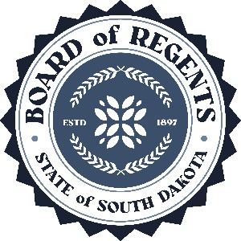 | SOUTH DAKOTA BOARD OF REGENTS  ACADEMIC AFFAIRS FORMS
Program Termination or
Placement on Inactive Status

Use this form to request termination or inactive status for an existing program (graduate program, undergraduate major or minor, certificate, or specialization). The Board of Regents, Executive Director, and/or their designees may request additional information about the proposal. After the university President approves the proposal, submit a signed copy to the Executive Director through the system Chief Academic Officer. Only post the form to the university website for review by other universities after approval by the Executive Director and Chief Academic Officer.

UNIVERSITY: | DSU
DEGREE(S) AND PROGRAM: | Professional and Technical Communication Certificate
CIP CODE: | 231303
UNIVERSITY DEPARTMENT: | Arts and Sciences
BANNER DEPARTMENT CODE: | DAS – 8A
UNIVERSITY DIVISION: | Language
BANNER DIVISION CODE: | DLAN

University Approval
To the Board of Regents and the Executive Director: I certify that I have read this proposal, that I believe it to be accurate, and that it has been evaluated and approved as provided by university policy.
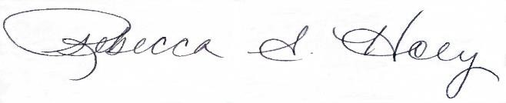 |  | 11/7/2023
Provost or President of the University |  | Date

- Program Degree Level (place an “X” in the appropriate box):

Associate | ☐ | Bachelor’s | ☐ | Master’s | ☐ | Doctoral | ☐

- Category (place an “X” in the appropriate box):

Certificate | ☒ | Specialization | ☐ | Minor | ☐ | Major | ☐

- The program action proposed is (place an “X” in the appropriate box):
Inactive Status | ☐ | Termination | ☒
See question 4 |  | See questions 5 and 6

- TERMINATION WITHOUT ENROLLED STUDENTS

  - Provide a justification for terminating the program:

The certificate does not have any students. We eliminated the BS Professional and Technical Communications degree program several years ago.

  - What is the proposed date (day/month/year) for the program to terminate (program status in the database changes to Deleted)?

Fall 2024

  - What are the potential cost savings of terminating the program and what are the planned uses of the savings?

DSU does not anticipate any cost savings by eliminating this certificate.

  - What are the resulting employee terminations and other possible implications including impact on other programs?

DSU does not anticipate any employee terminations because of the termination.

Note: Certificates, specializations, and minors may only be terminated and not placed on inactive status due to limitations in the student information system.
Note: An inactive program is a program a university has authority to offer, but the program is not admitting new students and has not formally terminated. A presumption exists that inactive status is a temporary status; universities review inactive programs periodically to determine the feasibility of reactivating or terminating the program. Programs can remain inactive for five (5) consecutive years at which time a university must terminate the program. A terminated program is a program for which a university ceases to have authority to offer. Reinstatement of a terminated program requires university and BOR approval through the prescribed new program approval processes.

