SOUTH DAKOTA BOARD OF REGENTS
ACADEMIC AFFAIRS FORMS

Minor Program Modification

Use this form to request minor changes in existing programs (majors, minors, certificates, or specializations). The university Vice President for Academic Affairs approves minor program modifications and they are included in the Annual Minor Program Modification Summary form.

UNIVERSITY: | DSU
PROGRAM TITLE: | Network and Security Administration, Minor
CIP CODE: | 111002
UNIVERSITY DEPARTMENT: | The Beacom College of Computer and Cyber Sciences
BANNER DEPARTMENT CODE: | DCOC
UNIVERSITY DIVISION: | Computer Science
BANNER DIVISION CODE: | DCSC

University Approval
To the Board of Regents and the Executive Director: I certify that I have read this proposal, that I believe it to be accurate, and that it has been evaluated and approved as provided by university policy.
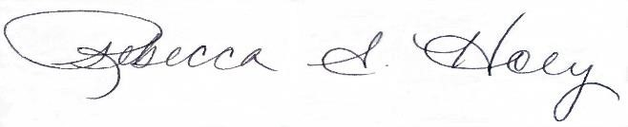 |  | 4/20/2023
Vice President of Academic Affairs or President of the University |  | Date

- This modification addresses a change in (place an “X” in the appropriate box):

☒ | Course deletions that do not change the nature of the program, or distribution of courses in the program, or change of total credit hours required | ☐ | Course additions that do not change the nature of the program, or distribution of courses in the program, or change of total credit hours required
☐ | Revised courses in the program.

- Effective date of change: 8/1/2023

- Program Degree Level (place an “X” in the appropriate box):

Associate | ☐ | Bachelor’s | ☐ | Master’s | ☐ | Doctoral | ☐

- Category (place an “X” in the appropriate box):

Certificate | ☐ | Specialization | ☐ | Minor | ☒ | Major | ☐

- Is the program associated with a current articulation agreement?
Yes |  | ☐ | No | ☒
  - If yes, will the articulation agreement need to be updated with the partner institution as a result of this minor program modification? Why or why not?

- Primary Aspects of the Modification (add lines or adjust cell size as needed):

Existing Curriculum |  |  |  |  | Proposed Curriculum (highlight changes)
Pref. | Num. | Title | Cr.  Hrs. |  |  | Pref. | Num. | Title | Cr. Hrs.
Required Courses |  |  | 20 |  |  | Required Courses |  |  | 20
CSC | 134 | Introduction to Cyber Operations | 3 |  |  | CSC | 134 | Introduction to Cyber | 3
 | or
CSC | 145 | Cyber Security Fundamentals
 |  | Total Hours Required | 20 |  |  |  |  | Total Hours Required | 20

- Explanation of the Change:

The proposal is to eliminate the choice between CSC 134 & CSC 145 and to require a single course. This will be beneficial for advising, consistency, program assessment, and CAE designation. The CSC 134 course will provide a common foundation for the key cybersecurity content necessary in the program.

