SOUTH DAKOTA BOARD OF REGENTS
ACADEMIC AFFAIRS FORMS

Minor Program Modification

Use this form to request minor changes in existing programs (majors, minors, certificates, or specializations). The university Vice President for Academic Affairs approves minor program modifications and they are included in the Annual Minor Program Modification Summary form.

UNIVERSITY: | DSU
PROGRAM TITLE: | AS Health Informatics and Information Management  BS Health Informatics and Information Management
CIP CODE: | 510707
UNIVERSITY DEPARTMENT: | Health Informatics & Information Management
BANNER DEPARTMENT CODE: | DHIM
UNIVERSITY DIVISION: | College of Business and Information Systems
BANNER DIVISION CODE: | DBIS – 8I

University Approval
To the Board of Regents and the Executive Director: I certify that I have read this proposal, that I believe it to be accurate, and that it has been evaluated and approved as provided by university policy.
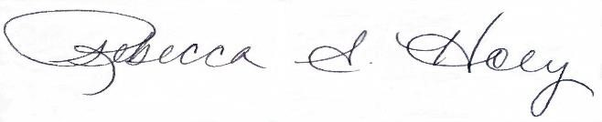 |  | 3/29/2023
Vice President of Academic Affairs or President of the University |  | Date

- This modification addresses a change in (place an “X” in the appropriate box):

☐ | Course deletions that do not change the nature of the program, or distribution of courses in the program, or change of total credit hours required | ☒ | Course additions that do not change the nature of the program, or distribution of courses in the program, or change of total credit hours required
☐ | Revised courses in the program.

- Effective date of change: 5/8/2023

- Program Degree Level (place an “X” in the appropriate box):

Associate | ☒ | Bachelor’s | ☒ | Master’s | ☐ | Doctoral | ☐

- Category (place an “X” in the appropriate box):

Certificate | ☐ | Specialization | ☐ | Minor | ☐ | Major | ☒

- Is the program associated with a current articulation agreement?
Yes |  | ☐ | No | ☒
  - If yes, will the articulation agreement need to be updated with the partner institution as a result of this minor program modification? Why or why not?

- Primary Aspects of the Modification (add lines or adjust cell size as needed):

Existing Curriculum |  |  |  |  | Proposed Curriculum (highlight changes)
Pref. | Num. | Title | Cr.  Hrs. |  |  | Pref. | Num. | Title | Cr. Hrs.
System General Education* |  |  | 30 |  |  | General Education* |  |  | 30
*Majors must take BIOL 106/106L, and either BIOL 101 or BIOL 151, and Math 114 as part of the System-wide General Education requirements. |  |  |  |  |  | * Majors must take BIOL 106/106L, and either BIOL 101 or BIOL 151, and MATH 114 or higher as part of the system-wide general education requirement

- Explanation of the Change:

Adding “or higher” to general education mathematics course selection.

