SOUTH DAKOTA BOARD OF REGENTS
ACADEMIC AFFAIRS FORMS
Authority to Offer an Existing Course

DSU |  | Arts and Sciences
Institution |  | Division/Department

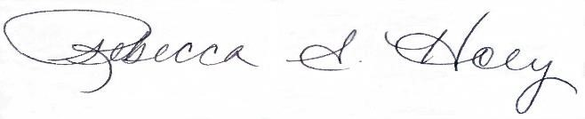 |  | 1/5/2023
Institutional Approval Signature |  | Date

- Is this a request to offer an existing common course or an existing unique course (approval will change course status from unique to common)?

Common Course | ☒
Unique Course | ☐

- Provide the complete description as it appears in the system database including pre-requisites and co-requisites.

Prefix & No. | Course Title | Credits
HIST 358 | The United States Since 1941 | 3

Course Description
Social, economic, and political change. The consequences, domestic and foreign, of global power and rising affluence.

Pre-requisites or Co-requisites (add lines as needed, make sure to copy boxes in Pre-req and Co-req cells)
Prefix & No. | Course Title | Pre-req | Co-req
 |  | Choose an item. | Choose an item.

- Universities currently offering this course (place an “X” in the appropriate boxes):

☐ | BHSU | ☐ | DSU | ☒ | NSU | ☐ | SDSMT | ☒ | SDSU | ☐ | USD

- Does Offering the Course Create FTE Implications? No

If no, Replacement of |  | The course will be built into the current history course rotation. |  | (deletion form attached)
 |  | (prefix, number, name of course, credits)
 | Effective Date of Deletion: |  | 8/21/2023

5. Does Offering the Course Create Schedule Management Implications? | No
Explain: This course will be offered as an elective in the major in a semester when the assigned faculty is not teaching some other class assigned to them.

6. Existing program(s) in which course will be offered: |  | Elective
7. CIP Code for the course: | 54.0102

8. Proposed instructional method by this university: | Lecture

8. Proposed delivery method by this university: | Face to face and online asynchronous

9. University Dept. Code: | DSOS

10. Authority to offer effective beginning in what term? | Fall 2023

11. Section Restriction: | NA

