SOUTH DAKOTA BOARD OF REGENTS
ACADEMIC AFFAIRS FORMS
Authority to Offer an Existing Course

DSU |  | College of Arts and Sciences
Institution |  | Division/Department

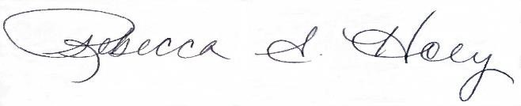 |  | 1/5/2023
Institutional Approval Signature |  | Date

- Is this a request to offer an existing common course or an existing unique course (approval will change course status from unique to common)?

Common Course | ☒
Unique Course | ☐

- Provide the complete description as it appears in the system database including pre-requisites and co-requisites.

Prefix & No. | Course Title |  | Credits
BIOL 235 | Introduction to Biotechnology |  | 3
Course Description
Presents a basic overview of biotechnology emphasizing current DNA and RNA technologies and structure and function of biomolecules. The application of these techniques in the fields of medicine, agriculture, forensics and the environment is emphasized. Scientific methods, current good laboratory practices (cGLP), standard operating procedures (SOP), environmental regulations and ethics of the biotechnology industry will also be covered.

Prefix & No. | Course Title |  | Credits
BIOL 235L | Introduction to Biotechnology Lab |  | 0
Course Description
Laboratory to accompany BIOL 235.

Pre-requisites or Co-requisites (add lines as needed, make sure to copy boxes in Pre-req and Co-req cells)
Prefix & No. | Course Title | Pre-req | Co-req
BIOL 235L | Introduction to Biotechnology Lab | No | Yes

- Universities currently offering this course (place an “X” in the appropriate boxes):

☐ | BHSU | ☐ | DSU | ☒ | NSU | ☐ | SDSMT | ☒ | SDSU | ☐ | USD

- Does Offering the Course Create FTE Implications? No

If no, Replacement of |  |  |  | (deletion form attached)
 |  | (prefix, number, name of course, credits)
 | Effective Date of Deletion: |  | 1/2/2023
Course will be taught with current faculty and will be added to the course rotation.

5. Does Offering the Course Create Schedule Management Implications? | No
Explain:

6. Existing program(s) in which course will be offered: |  | General Education Goal 6 Natural Sciences
7. CIP Code for the course: | 26.0202

8. Proposed instructional method by this university: | Lecture / Laboratory

8. Proposed delivery method by this university: | 001, 015 and 018

9. University Dept. Code: | DAS - DSCI

10. Authority to offer effective beginning in what term? Summer 2023

11. Section Restriction: | None

