SOUTH DAKOTA BOARD OF REGENTS
ACADEMIC AFFAIRS FORMS

Minor Program Modification

Use this form to request minor changes in existing programs (majors, minors, certificates, or specializations). The university Vice President for Academic Affairs approves minor program modifications and they are included in the Annual Minor Program Modification Summary form.

UNIVERSITY: | DSU
PROGRAM TITLE: | Health Information Management (HIM)
CIP CODE:
UNIVERSITY DEPARTMENT: | College of Business and Information Systems
BANNER DEPARTMENT CODE: | 8I
UNIVERSITY DIVISION: | Health Information Management
BANNER DIVISION CODE: | DHIM

University Approval
To the Board of Regents and the Executive Director: I certify that I have read this proposal, that I believe it to be accurate, and that it has been evaluated and approved as provided by university policy.
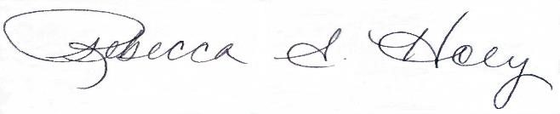 |  | 11/17/2022
Vice President of Academic Affairs or President of the University |  | Date

- This modification addresses a change in (place an “X” in the appropriate box):

☐ | Course deletions that do not change the nature of the program, or distribution of courses in the program, or change of total credit hours required | ☐ | Course additions that do not change the nature of the program, or distribution of courses in the program, or change of total credit hours required
☐ | Revised courses in the program.

- Effective date of change: 5/8/2023

- Program Degree Level (place an “X” in the appropriate box):

Associate | ☒ | Bachelor’s | ☒ | Master’s | ☒ | Doctoral | ☐

- Category (place an “X” in the appropriate box):

Certificate | ☐ | Specialization | ☐ | Minor | ☐ | Major | ☒

- Is the program associated with a current articulation agreement?
Yes |  | ☒ | No | ☐
  - If yes, will the articulation agreement need to be updated with the partner institution as a result of this minor program modification? Why or why not?

- Primary Aspects of the Modification (add lines or adjust cell size as needed):

Health Information Management Program |  | Health Informatics and Information Management Program

- Explanation of the Change:

This proposal is to change the Health Information Management Program name to Health Informatics and Information Management Program. Currently the AS, BS and MS majors under the program have all changes names to Health Informatics and Information Management. This change in program change will reflect the majors that fall under that program.

The majors are accredited by CAHIIM and the program name change will not cause issues.

The university will also be asking that the Banner Department Code description be changed from Health Information Management to Health Informatics and Information Management. The Code (DHIM) will remain the same but the description of that code will change.

