SOUTH DAKOTA BOARD OF REGENTS
ACADEMIC AFFAIRS FORMS
New Undergraduate Degree Program

Use this form to propose a new undergraduate degree program. An undergraduate degree program includes a new major, a new degree, or both. The Board of Regents, Executive Director, and/or their designees may request additional information about the proposal. After the university President approves the proposal, submit a signed copy to the Executive Director through the system Chief Academic Officer. Only post the New Undergraduate Degree Program Form to the university website for review by other universities after approval by the Executive Director and Chief Academic Officer.

UNIVERSITY: | DSU
MAJOR:
EXISTING OR NEW MAJOR(S): | Business Analytics
DEGREE:
EXISTING OR NEW DEGREE(S): | Associate of Science
INTENDED DATE OF IMPLEMENTATION: | Fall 2022
PROPOSED CIP CODE: | 11.0401
SPECIALIZATIONS:  Note: If the new proposed program includes specific specializations within it, complete and submit a New Specialization Form for each proposed specialization and attach it to this form. Since specializations appear on transcripts, they require Board approval. | None
IS A SPECIALIZATION REQUIRED (Y/N): | No
DATE OF INTENT TO PLAN APPROVAL: | Click here to enter a date.
UNIVERSITY DEPARTMENT: | College of Business and Info Systems
BANNER DEPARTMENT CODE: | DCBIS - 81
UNIVERSITY DIVISION: | Information Systems
BANNER DIVISION CODE: | DINF

☒Please check this box to confirm that:
- The individual preparing this request has read AAC Guideline 2:9, which pertains to new undergraduate degree program requests, and that this request meets the requirements outlined in the guidelines.
- This request will not be posted to the university website for review of the Academic Affairs Committee until it is approved by the Executive Director and Chief Academic Officer.

University Approval
To the Board of Regents and the Executive Director: I certify that I have read this proposal, that I believe it to be accurate, and that it has been evaluated and approved as provided by university policy.

 |  | 11/4/2021
President of the University |  | Date

- What is the nature/purpose of the proposed program? Please include a brief (1-2 sentence) description of the academic field in this program.

Dakota State University (DSU) requests authorization to offer an Associate of Science (A.S.) in Business Analytics. Business Analytics is one of the fastest growing fields and there is a high demand for graduates who can apply data science and machine learning to solve business problems. DSU already has a Business Analytics Specialization in the B.S. degree in Computer Information Systems. This A.S. degree will prepare graduates for entry-level work in a variety of fields as well as provide transfer options to the baccalaureate program. Examples of entry level job opportunities includes data analyst associate, data conversion analyst, business analyst, marketing analyst, business intelligence analyst, business process analyst, operations analyst, and others. The curriculum for this degree has been designed to allow students who complete the 60 credits of coursework to seek immediate employment in the field or to use the degree towards completion of the baccalaureate degree in Computer Information Systems.

- How does the proposed program relate to the university’s mission and strategic plan, and to the current Board of Regents Strategic Plan 2014-2020?

Under SDCL 13-59, the primary purpose of Dakota State University at Madison in Lake County is to provide instruction in computer management, computer information systems, electronic data processing, and other related undergraduate and graduate programs.

The most recent DSU Strategic Plan includes goals that are directly related to this program request:
- Offer innovative and robust academic programs that link to our mission.
- Infuse innovative technology in the delivery of academic programs.
- Optimize undergraduate and graduate enrollments.
The proposed associate degree in Business Analytics supports all of these strategic directions for DSU. The proposed program aligns with the Board of Regents Strategic Plan 2014-2020, including but not limited to the following goals:

- Grow undergraduate and graduate degrees awarded.
- Increase the number of graduates from STEM programs.
- Encourage campuses to increase recruitment and retention of undergraduate STEM majors.
- Encourage development of academic programs and certificates that align with existing and future state workforce needs.

- Describe the workforce demand for graduates of the program, including national demand and demand within South Dakota.

Data analysts are asked to bring sense and direction to accumulated data in just about every form and for just about every end purpose. It is a key foundational position in all data and technology-related business functions, and one that is currently in tremendous demand. While the US Department of Labor does not provide employment statistics, other online sources provide the following estimates. The average salary for data analysts is approximately $47,000 per year ranging from a low of $30,000 to a high of $59,000, according to PayScale.com. Bonuses, commissions and profit sharing can add up to an additional $4,000.

According to Statista.com, the global data analytics market was valued at $215 Billion USD in 2021. More importantly, according to Deloitee, there is a significant data talent shortage.

- How will the proposed program benefit students?

This associate degree provides individuals with broad topics that would be useful for any entry level position requiring business analytics skills in any business and/or industry. It will also allow them to continue seamlessly into the B.S. CIS with a specialization in Business Analytics.

- Program Proposal Rationale:

  - If a new degree is proposed, what is the rationale?

Not applicable

  - What is the rationale for the curriculum?

Because this program is directly stackable into the BS degree without any courses not used elsewhere and already taught, there will be no new courses associated with this degree. It allows students to have these “milestones” accomplished on their academic road toward a future BS degree.

  - Demonstrate/provide evidence that the curriculum is consistent with current national standards.

The proposed curriculum is in line with national curriculum recommendations per the expectations at DiscoverDataScience.org for the Data Science and Data Analytics Associate Programs. The proposed curriculum also aligns well with studydatacience.org’s expectations.

  - Summary of the degree program (complete the following tables):

AS in Business Analytics | Credit Hours | Credit Hours | Percent
System General Education Requirements | 24*
Subtotal, Degree Requirements |  | 24 | 40%
Required Support Courses (not included above) | 6
Major Requirements | 27
Major Electives | 3
Subtotal, Program Requirements |  | 36 | 60%
Free Electives |  | 0
Degree Total |  | 60 | 100%
* ECON 201 must be taken as one of the SGE Social Study required courses.
Required Support Courses Outside the Major
(Not general education requirements)
Prefix | Number | Course Title | Prerequisite | Credit Hours | New  (yes, no)
BADM | 220 | Business Statistics | MATH 114 | 3 | No
BADM | 321 | Business Statistics II | BADM 220 | 3 | No
 |  | Subtotal |  | 6

Major Requirements
Prefix | Number |  | Course Title  (add or delete rows as needed) | Prerequisite | Credit Hours | New  (yes, no)
CSC | 105 |  | Introduction to Computers |  | 3 | No
CSC | 150 |  | Computer Science I |  | 3 | No
CIS | 251 |  | Business Applications Programming | CSC 150 | 3 | No
CIS | 325 |  | Management Information Systems |  | 3 | No
CIS | 368 |  | Predictive Analytics | CIS 372 & BADM 220 | 3 | No
CIS | 372 |  | Programming for Analytics | CSC 150 | 3 | No
CIS | 474 |  | Business Intelligence and Big Data | CIS 251 | 3 | No
CIS | 484 |  | Database Management Systems |  | 3 | No
 |  | Choose three credits from the following four courses 3
CIS | 206 |  | Advanced Applications |  | 1 | No
CIS | 207 |  | Advanced Applications: Spreadsheets |  | 1 | No
CIS | 208 |  | Advanced Applications: Database |  | 1 | No
CIS | 210 |  | QuickBooks I |  | 1 | No
 |  |  | Subtotal |  | 27

Major Electives: List courses available as electives in the program. Indicate any proposed new courses added specifically for the major.
Prefix | Number | Course Title | Credit Hours | New  (yes, no)
BADM or CIS or CSC |  | Any BADM, CIS or CSC course | 3 | No
 |  | Subtotal | 3

- Student Outcomes and Demonstration of Individual Achievement

  - What specific knowledge and competencies, including technology competencies, will all students demonstrate before graduation?
 | Program Courses that Address the Outcomes
Individual Student Outcome | BADM  220 | BADM  321 | CSC  105/  150 | CIS (6,7,  8,10) | CIS  325 | CIS  251
Use essential analytics tools to visualize, analyze, clean and work with data to support decisionmaking functions and evaluate results. |  |  | X | X |  | X
Draw accurate conclusions from data analyses of real-world problems with a business-focused mindset. | X | X |  |  | X
Use supervised an unsupervised learning techniques on data to achieve tasks such as classification, regression, clustering, association and dimensionality reduction.
Independently solve business problems using analytics
Develop the ability to effectively extract insight from data and communicate the insights with stakeholders.

 | Program Courses that Address the Outcomes
Individual Student Outcome  (Same as in the text of the proposal) | CIS  368 | CIS  372 | CIS  474 | CIS  484
Use essential analytics tools to visualize, analyze, clean and work with data to support decisionmaking functions and evaluate results. | X | X | X | X
Draw accurate conclusions from data analyses of real-world problems with a business-focused mindset. | X | X | X | X
Use supervised an unsupervised learning techniques on data to achieve tasks such as classification, regression, clustering, association and dimensionality reduction. | X |  | X
Independently solve business problems using analytics | X | X
Develop the ability to effectively extract insight from data and communicate the insights with stakeholders. | X | X | X | X

  - Are national instruments (i.e., examinations) available to measure individual student achievement in this field? If so, list them.

No

  - How will individual students demonstrate mastery? Describe the specific examinations and/or processes used, including any external measures (including national exams, externally evaluated portfolios, or student activities, etc.). What are the consequences for students who do not demonstrate mastery?

Students will take the AS in Business Analytics major field assessment.

- What instructional approaches and technologies will instructors use to teach courses in the program?

Instructors will use projectors to display notes, slides, and other materials including interactive Jupyter Notebook documents from their computers to the students. Classes taught online will have videos that stream synchronously or be recorded for later playback.

- Did the University engage any developmental consultants to assist with the development of the curriculum? Did the University consult any professional or accrediting associations during the development of the curriculum? What were the contributions of the consultants and associations to the development of curriculum?

No

- Are students enrolling in the program expected to be new to the university or redirected from other existing programs at the university? Complete the table below and explain the methodology used in developing the estimates (replace “XX” in the table with the appropriate year). If question 12 includes a request for authorization for off-campus or distance delivery, add lines to the table for off-campus/distance students, credit hours, and graduates.

 | Fiscal Years*
 | 1st | 2nd | 3rd | 4th
Estimates | FY 22 | FY 23 | FY 24 | FY 25
Students new to the university | 5 | 5 | 5 | 5
Students from other university programs
Students off-campus or distance | 2 | 2 | 2 | 2
Continuing students |  | 7 | 7 | 7
=Total students in the program (fall) | 7 | 14 | 14 | 14
Program credit hours (major courses)** | 126 | 252 | 252 | 252
Graduates |  | 7 | 7 | 7
*Do not include current fiscal year.
**This is the total number of credit hours generated by students in the program in the required or elective program courses. Use the same numbers in Appendix B – Budget.

The Bachelor’s degree that this proposed major stacks into is Computer Information Systems (CIS). CIS has three specializations, one of which is Business Analytics. Of the three speciallizations the Business Analytics has the highest enrollments, currently at 28. The AS in Business Analtyics will stack directly into the Business Analytics specialization. Therefore, we anticipate at least 7 students will select this major.

- Is program accreditation available? If so, identify the accrediting organization and explain whether accreditation is required or optional, the resources required, and the University’s plans concerning the accreditation of this program.

No

- Does the University request any exceptions to any Board policy for this program? Explain any requests for exceptions to Board Policy. If not requesting any exceptions, enter “None.”

AAC guidelines indicate Associate of Science degrees can have up to sixteen (16) credits at the 300-400 level. This program has 4 courses at the 300 level and 2 courses at the 400 level. DSU is asking for an exception for the program.
- Delivery Location

- Complete the following charts to indicate if the university seeks authorization to deliver the entire program on campus, at any off campus location (e.g., USD Community Center for Sioux Falls, Black Hills State University-Rapid City, Capital City Campus, etc.) or deliver the entire program through distance technology (e.g., as an online program)?

 | Yes/No | Intended Start Date
On campus | Yes | Fall 2022

 | Yes/No | If Yes, list location(s) | Intended Start Date
Off campus | No |  | Choose an item. Choose an item.

 | Yes/No | If Yes, identify delivery methods  Delivery methods are defined in AAC Guideline 5.5. | Intended Start Date
Distance Delivery (online/other distance delivery methods) | Yes | 015 | Fall 2022
Does another BOR institution already have authorization to offer the program online? | No | If yes, identify institutions:

- Complete the following chart to indicate if the university seeks authorization to deliver more than 50% but less than 100% of the program through distance learning (e.g., as an online program)? This question responds to HLC definitions for distance delivery.

 | Yes/No | If Yes, identify delivery methods | Intended Start Date
Distance Delivery (online/other distance delivery methods) | No |  | Choose an item. Choose an item.

- Cost, Budget, and Resources: Explain the amount and source(s) of any one-time and continuing investments in personnel, professional development, release time, time redirected from other assignments, instructional technology & software, other operations and maintenance, facilities, etc., needed to implement the proposed major. Address off-campus or distance delivery separately.

The College of Business and Information System will use existing courses and faculty so no additional budget is being sought. The additional students anticipated in this major can be accommodated with no additional sections being planned.

- Is the university requesting or intending to request permission for a new fee or to attach an existing fee to the program (place an “X” in the appropriate box)? If yes, explain.

☐ |  | ☒
Yes |  | No

Explanation (if applicable):

- New Course Approval: New courses required to implement the new undergraduate degree program may receive approval in conjunction with program approval or receive approval separately. Please check the appropriate statement:

☐ | YES,
the university is seeking approval of new courses related to the proposed program in conjunction with program approval. All New Course Request forms are included as Appendix C and match those described in section 5D.

☒ | NO,
the university is not seeking approval of all new courses related to the proposed program in conjunction with program approval; the institution will submit new course approval requests separately or at a later date in accordance with Academic Affairs Guidelines.

Appendix A
Proprietary website that requires credentials
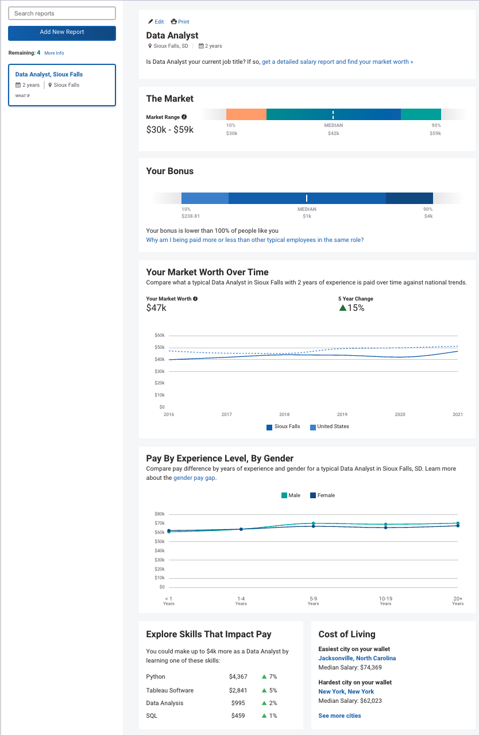

https://www.payscale.com/mypayscale.aspx?loggedIn (see Appendix A)
https://www.statista.com/statistics/551501/worldwide-big-data-business-analytics-revenue/
https://www2.deloitte.com/us/en/insights/industry/technology/data-analytics-skills-shortage.html
https://www.discoverdatascience.org/programs/associate-in-data-science/
https://studydatascience.org/degrees/associates/

