SOUTH DAKOTA BOARD OF REGENTS
ACADEMIC AFFAIRS FORMS
Program Termination or
Placement on Inactive Status

Use this form to request termination or inactive status for an existing program (graduate program, undergraduate major or minor, certificate, or specialization). The Board of Regents, Executive Director, and/or their designees may request additional information about the proposal. After the university President approves the proposal, submit a signed copy to the Executive Director through the system Chief Academic Officer. Only post the form to the university website for review by other universities after approval by the Executive Director and Chief Academic Officer.

UNIVERSITY: | DSU
DEGREE(S) AND PROGRAM: | BS in Biology: DBS.BIO
CIP CODE: | 26.9999
UNIVERSITY DEPARTMENT: | Sciences
BANNER DEPARTMENT CODE: | DSCI
UNIVERSITY DIVISION: | College of Arts and Sciences
BANNER DIVISION CODE: | 8A

University Approval
To the Board of Regents and the Executive Director: I certify that I have read this proposal, that I believe it to be accurate, and that it has been evaluated and approved as provided by university policy.

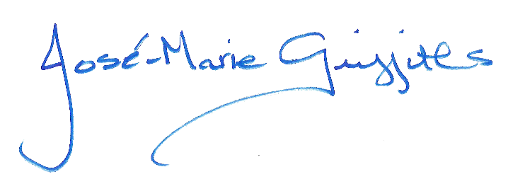 |  | 3/11/2022
President of the University |  | Date

- Program Degree Level (place an “X” in the appropriate box):

Associate | ☐ | Bachelor’s | ☒ | Master’s | ☐ | Doctoral | ☐

- Category (place an “X” in the appropriate box):

Certificate | ☐ | Specialization | ☐ | Minor | ☐ | Major | ☒

- The program action proposed is (place an “X” in the appropriate box):
Inactive Status | ☐ | Termination | ☒
See question 4 |  | See questions 5 and 6

- TERMINATION WITH ENROLLED STUDENTS

  - Provide a justification for terminating the program:

The program (DBS.BIO) has been replaced by a new specialization-bearing program (DBS.BIO-IBI; IBI = Integrative Biology).

  - What is the plan for completion of the program by current students?

Students previously enrolled in DBS.BIO have either graduated from this program or transfer to the newly created program (DBS.BIO-IBI).

  - What is the proposed term for which program termination status begins? (Note: program controls in Banner reflects Phasing Out status, which means all functionality except graduation is shut off.)

202150 (summer 2021)

  - What is the last term by which previously enrolled students must graduate from the program? (Note: as of this term, all functionalities will be shut down.)

202580 (fall 2025)

  - What are the potential cost savings of terminating the program and what are the planned uses of the savings?

DSU does not anticipate cost savings other than course rotation efficiencies.

  - What are the resulting employee terminations and other possible implications including impact on other programs?

Not applicable

  - What are the resulting employee terminations and other possible implications including impact on other programs?

None

Note: Certificates, specializations, and minors may only be terminated and not placed on inactive status due to limitations in the student information system.
Note: An inactive program is a program a university has authority to offer, but the program is not admitting new students and has not formally terminated. A presumption exists that inactive status is a temporary status; universities review inactive programs periodically to determine the feasibility of reactivating or terminating the program. Programs can remain inactive for five (5) consecutive years at which time a university must terminate the program. A terminated program is a program for which a university ceases to have authority to offer. Reinstatement of a terminated program requires university and BOR approval through the prescribed new program approval processes.

