SOUTH DAKOTA BOARD OF REGENTS
ACADEMIC AFFAIRS FORMS
New Specialization

UNIVERSITY: | DSU
TITLE OF PROPOSED SPECIALIZATION: | Software Engineering
NAME OF DEGREE PROGRAM IN WHICH SPECIALIZATION IS OFFERED: | B.S. in Computer Science
INTENDED DATE OF IMPLEMENTATION: | 5/10/2019
PROPOSED CIP CODE: | 11.0101
UNIVERSITY DEPARTMENT: | Beacom College of Computer and Cyber Sciences
UNIVERSITY DIVISION: | Computer Science

University Approval
To the Board of Regents and the Executive Director: I certify that I have read this proposal, that I believe it to be accurate, and that it has been evaluated and approved as provided by university policy.

 |  | 9/25/2018
Institutional Approval Signature  President or Chief Academic Officer of the University |  | Date

- Level of the Specialization (place an “X” in the appropriate box):

Baccalaureate | ☒ | Master’s | ☒ | Doctoral | ☐

- What is the nature/purpose of the proposed specialization?

The Beacom College of Computer and Cyber Sciences seeks to add a new specialization, Software Engineering, to the BS in Computer Science. The current faculty recruiting cycle will result in the faculty talent to be able to offer the courses. Software engineering is the systematic development and application of techniques leading to the creation of correct and reliable software. It has been also defined as “The application of a systematic, disciplined, quantifiable approach to the development, operation and maintenance of software.” The general nature and purpose of the program is to support businesses as many businesses generate their own computer programs or needs to personalize third-party software and needs software engineers/developers to write, edit and test programs. Software engineering is a rapidly changing field; most software developers continue to learn on the job, as languages and development environments evolve.

Given the mission specificity within the Beacom College, and the size and complexity of the college (30+ FTE Faculty) and its programs (Computer Game Design, B.S., Computer Science, B.S., Cyber Operations, B.S., Network and Security Administration, B.S. and other minors and certificates), DSU and the Beacom College is the appropriate place to offer this specialization. All the courses listed in the specialization are existing courses, so no new courses will be required.

- Provide a justification for the specialization, including the potential benefits to students and potential workforce demand for those who graduate with the credential.
Adding the Software Engineering specialization to the curriculum of the Beacom College is consistent with the board-designated mission of the college and of Dakota State University and supports our system, university and college goals pertaining to student success (this specialization will enhance student success), contribute to the state’s workforce and economic development as this program aligns nicely with existing and future state workforce needs.
DSU currently has a A.S. in Software Development and this addition to the Computer Science major will allow students to move from the Software Development major to the B.S. in Computer Science, Software Engineering Specialization or to the proposed B.S. Software Engineering major. Both bachelor’s degrees would then feed into the proposed M.S. in Software Engineering major, creating stackable credentials in software engineering. These graduates will provide project leadership and technical guidance along every stage of the software development life cycle. DSU is developing a stackable progression in this area. Starting with the current AS in software development at DSU or other schools, a student will be able to stack those credits into the BS in Software Engineering degree or at least the specialization. This provides the student the opportunity to scaffold of their software engineering skill set while the college can use the courses most efficiently.
Software engineering is a fast growing occupational field nationally and in South Dakota. In most cases, a bachelor's degree, usually in computer science, computer systems engineering, software engineering or mathematics or completion of a college program in computer science is required to become a software engineer. The addition of a specialization in software engineering to the BS in computer science will provide additional employment opportunities to graduates in this field.
The U.S. Bureau of Labor Statistics (BLS) projects that jobs for software developers will grow by 17% from 2014 to 2024, making software engineering one of the faster growing sectors in the job market.
From the Occupational Outlook Handbook (https://www.bls.gov/ooh/computer-and-information-technology/software-developers.htm), there is evidence of a growing need for software development professionals.
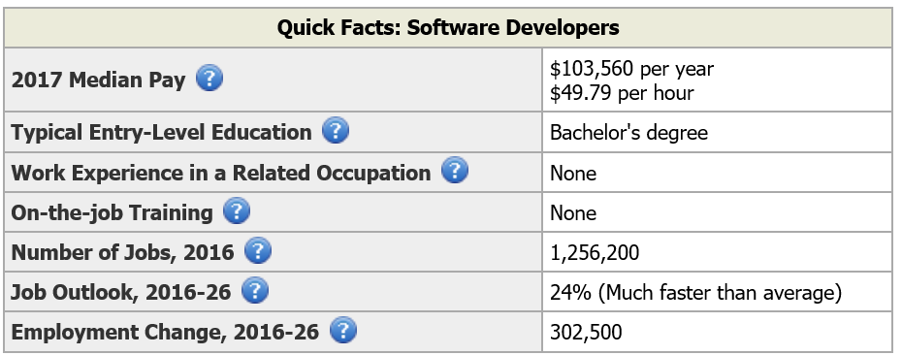
In addition to national demand, strong growth is expected for positions as software engineers within South Dakota. This section needs some South Dakota data. For example, the SD Department of Labor and Regulation notes that employment of software developers is expected to grow between 14-24% in Rapid City and Sioux Falls with a total of about 24 annual job openings in those two cities through 2024.

- List the proposed curriculum for the specialization (including the requirements for completing the major – highlight courses in the specialization):

Prefix | Number | Course Title |  | Credit Hours | New  (yes, no)
 |  | System General Education |  | 30
 |  | Required Support Courses |  | 19
 |  | BS in Computer Science Requirements:
CIS  CSC | 332  321 | Structured Systems Analysis and Design  OR  Information Security Management |  | 3 | NO
CSC | 105 | Introduction to Computers |  | 3 | NO
CSC | 150 | Computer Science |  | 3 | NO
CSC | 234 | Software Security |  | 3 | NO
CSC | 250 | Computer Science II |  | 3 | NO
CSC | 260 | Object Oriented Design |  | 3 | NO
CSC | 300 | Data Structures |  | 3 | NO
CSC | 310 | Advanced Data Structures |  | 3 | NO
CSC | 314 | Assembly Language |  | 3 | NO
CSC | 383 | Networking |  | 3 | NO
CSC | 404 | Foundation of Computation |  | 3 | NO
CSC | 410 | Parallel Computing |  | 3 | NO
CSC | 456 | Operating Systems |  | 3 | NO
CSC | 461 | Programming Languages |  | 3 | NO
CSC | 470 | Software Engineering |  | 3 | NO
CSC | 482 | Algorithms and Optimization |  | 3 | NO
 |  | Select three 300-400-level CIS/CSC courses (CIS 275 is allowed; CIS 350 is not allowed) |  | 9 | NO
 |  | Software Engineering Specialization Requirements:
CIS | 275 | Web Application Programming I |  | 3 | No
CIS | 375 | Web Application Programming II |  | 3 | No
Pick 6 credits from the following (any two of the 5 below) |  |  |  | 6 | Choose an item.
CIS | 476 | Web Development Environments |  | 3 | No
CIS | 451 | Mobile Development Environments |  | 3 | No
CSC | 443 | Scripting for Network Administration |  | 3 | No
CSC | 455 | Development of Environments & Tools |  | 3 | Yes
CSC | 470 | Software Engineering |  | 3 | No
Total number of hours required for completion of specialization |  |  |  | 12
Total number of hours required for completion of major |  |  |  | 57
Total number of hours required for completion of degree |  |  |  | 120

- Delivery Location

A. Complete the following charts to indicate if the university seeks authorization to deliver the entire program on campus, at any off-campus location (e.g., UC Sioux Falls, Capital University Center, Black Hills State University-Rapid City, etc.) or deliver the entire program through distance technology (e.g., as an on-line program)?

 | Yes/No | Intended Start Date
On campus | Yes | Fall 2018

 | Yes/No | If Yes, list location(s) | Intended Start Date
Off campus | No |  | Choose an item. Choose an item.

 | Yes/No | If Yes, identify delivery methods | Intended Start Date
Distance Delivery (online/other distance delivery methods) | Yes | Online primarily synchronous delivery | Fall 2019

B. Complete the following chart to indicate if the university seeks authorization to deliver more than 50% but less than 100% of the certificate through distance learning (e.g., as an on-line program)?

 | Yes/No | If Yes, identify delivery methods | Intended Start Date
Distance Delivery (online/other distance delivery methods) | No |  | Choose an item. Choose an item.

- Additional Information: Additional information is optional. Use this space to provide pertinent information not requested above. Limit the number and length of additional attachments. Identify all attachments with capital letters. Letters of support are not necessary and are rarely included with Board materials. The University may include responses to questions from the Board or the Executive Director as appendices to the original proposal where applicable. Delete this item if not used.

Appendix A attached which describes DSU’s stackable software engineering credentials.

APPENDIX A
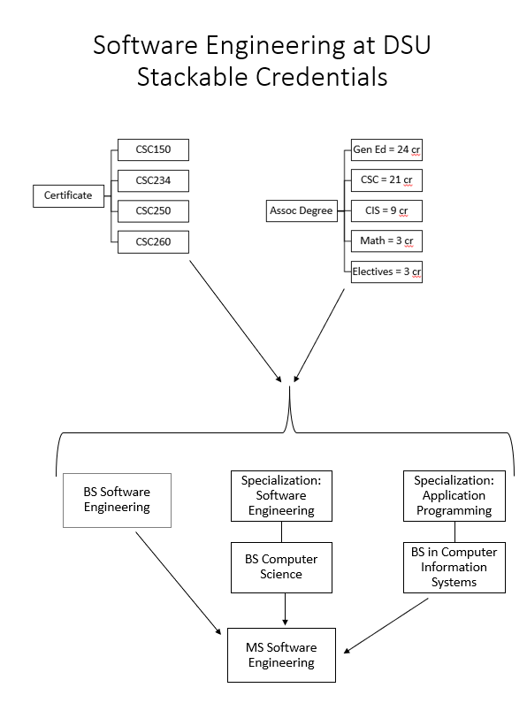

For workforce related information, please provide data and examples; data sources may include but are not limited to the South Dakota Department of Labor, the US Bureau of Labor Statistics, Regental system dashboards, etc.
https://www.bls.gov/ooh/computer-and-information-technology/software-developers.htm
Labor Market Information Center, South Dakota Department of Labor and Regulation, July 2017. Available from https://dlr.sd.gov/lmic/documents/substate_occupational_projections_2014_2024.xlsx
The Higher Learning Commission (HLC) and Board of Regents policy requires approval for a university to offer programs off-campus and through distance delivery.
Delivery methods are defined in AAC Guideline 5.5.
This question responds to HLC definitions for distance delivery.

