SOUTH DAKOTA BOARD OF REGENTS
ACADEMIC AFFAIRS FORMS
Existing Courses Minor Modification

Use this form to request minor modifications of existing unique and common courses. Consult the system database through Colleague or the Course Inventory Report for information about existing courses before submitting this form. If the course revision is for an approved General Education course, please see the Revision to General Education Requirements Form.

DSU |  | Arts & Sciences |  | Sandra Champion and Peter Kim |  | 11/22/2017
Institution |  | Division/Department |  | Originator |  | Date
Ryan English |  | Ben Jones |  | 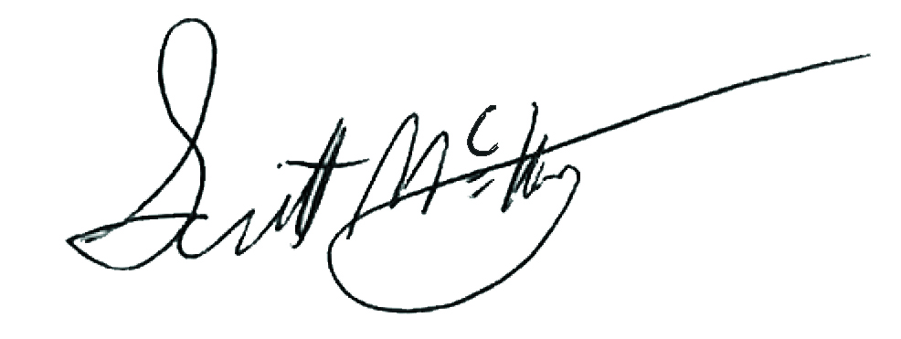 |  | 2/1/2018
Department Coordinator |  | College Dean |  | Institutional Approval Signature |  | Date

Section 1. Existing Course Title and Description

Prefix & No. | Course Title | Credits
MUS 204 | Introduction to American Pop Music | 3

Effective Date: | 5/15/2018

This course is a (Place an “X” in the appropriate box):
☒ | Unique Course (see section 2) |  | ☐ | Common Course (see section 3)

Section 2. Unique Courses: Requested Minor Modifications
Place an “X” in the appropriate boxes.

 |  | Current |  | New
☐ | Prefix change |  | to

☐ | Course Number change |  | to
NOTE: You may only change a unique course number to a number not currently used in “active” status at another university. Consult the system database in Colleague or the Course Inventory Report.

☐ | Credit hours |  | to

☒ | Course pre-requisites | None | to | CSC 105

☐ | Course co-requisites |  | to

☐ | Registration restriction |  | to

☐ | Enrollment limitation |  | to

☐ | Repeatable for additional credit |  | to

☐ | Grading option |  | to

☐ | Course title change
NOTE: The Enrollment Services Center assigns the short, abbreviated course title that appears on transcripts. The short title is limited to 30 characters (including spaces); meaningful but concise titles are encouraged due to space limitations in Colleague.

☐ | Cross-listing and equating with

☐ | Dual-listing at 400/500 level

☒ | Course description (that does not change course content). Complete table below:

Existing description:
An introduction to the history of popular music in America and the diversity of current styles including classic rock, hard rock, country, jazz, Rhythm and Blues, blues, Latin, rap, reggae, alternative, folk, techno, and others. The emphasis of the course is on listening to music and exploring relationships of popular music to society.

New description:
A foundation study of digital audio editing with the perspective of sound design. Topics including sampling, dB, microphone, and basic sound design techniques on current DAW software matched with given video file format. Also includes basic MIDI production applications and editing sound for video.

☐ | Add course in x9x series
 | CIP Code:

New to this university? |  | ☐ | Yes | ☐ | No

Will this university’s sections of the course be limited to S/U (pass/fail)?

 | ☐ | Yes | ☐ | No

☐ | Delete Course (effective date): | Click here to enter a date.

Justification for changes indicated in Section 2:
To make the Digital Arts and Design Program more collaborative, the Digital Sound Design Specialization (formerly Audio Production) identified this unique course as having potential to become a collaborative course in the core requirements. Course description changes will enhance the flexibility and interdisciplinary nature of the course, allowing it to fully function in the core course offerings for the major. Formerly, the course was Audio Production Specific, with low enrollment and no interdisciplinary scope. The course description and prerequisite changes facilitate greater interdisciplinary collaboration, increase class size, and enriches the artistic experience and education of the Digital Arts and Design Major.

Section 3. Common Courses: Requested Minor Modifications
Place an “X” in the appropriate boxes.

 |  | Current |  | New
☐ | Credit hours (within variable limits) |  | to

☐ | University specific co-requisites |  | to

☐ | Cross-listing and equating with

☐ | Dual-listing at 400/500 level

☐ | Add course in x9x series
 | CIP Code:

New to this university? |  | ☐ | Yes | ☐ | No

Will this university’s sections of the course be limited to S/U (pass/fail)?

 | ☐ | Yes | ☐ | No

☐ | x9x grading method |  | to

Justification for changes indicated in Section 3:

Section 4. Department and Course Codes (Completed by University Academic Affairs)

4.1. University department code:

4.2. Change university department code to:

