SOUTH DAKOTA BOARD OF REGENTS
ACADEMIC AFFAIRS FORMS
Existing Courses Minor Modification

Use this form to request minor modifications of existing unique and common courses. Consult the system database through Colleague or the Course Inventory Report for information about existing courses before submitting this form. If the course revision is for an approved General Education course, please see the Revision to General Education Requirements Form.

DSU |  | College of Arts & Sciences |  | Sandra Champion and Peter Kim |  | 11/22/2017
Institution |  | Division/Department |  | Originator |  | Date
Ryan English |  | Benjamin Jones |  | 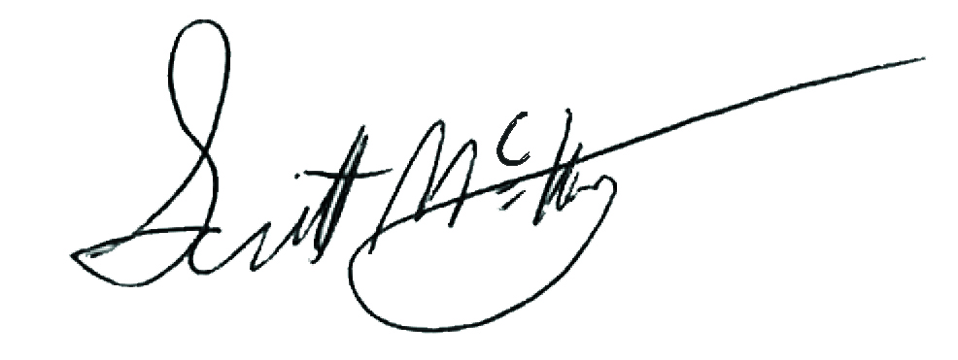 |  | 1/30/2018
Department Coordinator |  | School/College Dean |  | Institutional Approval Signature |  | Date

Section 1. Existing Course Title and Description

Prefix & No. | Course Title | Credits
DAD 423 | MIDI Techniques | 3

Effective Date: | Fall 18

This course is a (Place an “X” in the appropriate box):
☒ | Unique Course (see section 2) |  | ☐ | Common Course (see section 3)

Section 2. Unique Courses: Requested Minor Modifications
Place an “X” in the appropriate boxes.

 |  | Current |  | New
☐ | Prefix change |  | to

☐ | Course Number change |  | to
NOTE: You may only change a unique course number to a number not currently used in “active” status at another university. Consult the system database in Colleague or the Course Inventory Report.

☐ | Credit hours |  | to

☒ | Course pre-requisites | DAD 322 | to | MUS 108 and DAD 322

☐ | Course co-requisites |  | to

☐ | Registration restriction |  | to

☐ | Enrollment limitation |  | to

☐ | Repeatable for additional credit |  | to

☐ | Grading option |  | to

☒ | Course title change | Electroacoustic Sound Creation with MIDI
NOTE: The Enrollment Services Center assigns the short, abbreviated course title that appears on transcripts. The short title is limited to 30 characters (including spaces); meaningful but concise titles are encouraged due to space limitations in Colleague.

☐ | Cross-listing and equating with

☐ | Dual-listing at 400/500 level

☒ | Course description (that does not change course content). Complete table below:

Existing description:
Students learn to create and edit musical soundtracks at MIDI and DAW workstations for synchronization to video, presentation software and multimedia projects. Emphasis is given to understanding SMPTE and MIDI time clocks to synchronize video and audio compositions.

New description:
Students learn to create and edit creative sound and musical soundtracks through MIDI and DAWs not only for their own songwriting process but also for synchronizing to various video formats, presentation software, and multimedia projects. Emphasis is given to manipulate SMPTE and MIDI time clocks in order to communicate with professional post-processing experts as well.

☐ | Add course in x9x series
 | CIP Code:

New to this university? |  | ☐ | Yes | ☐ | No

Will this university’s sections of the course be limited to S/U (pass/fail)?

 | ☐ | Yes | ☐ | No

☐ | Delete Course (effective date): | Click here to enter a date.

Justification for changes indicated in Section 2:
Efforts to increase interdisciplinary collaboration in the Digital Arts and Design program lead to an enrichment and specification of DAD 423 MIDI Techniques. This new course name, description, and prerequisites reflect this enhanced curriculum, which is now Digital Sound Design. With these changes, this course now is in line with latest developments in the field of Digital Sound Design.

Section 3. Common Courses: Requested Minor Modifications
Place an “X” in the appropriate boxes.

 |  | Current |  | New
☐ | Credit hours (within variable limits) |  | to

☐ | University specific co-requisites |  | to

☐ | Cross-listing and equating with

☐ | Dual-listing at 400/500 level

☐ | Add course in x9x series
 | CIP Code:

New to this university? |  | ☐ | Yes | ☐ | No

Will this university’s sections of the course be limited to S/U (pass/fail)?

 | ☐ | Yes | ☐ | No

☐ | x9x grading method |  | to

Justification for changes indicated in Section 3:

Section 4. Department and Course Codes (Completed by University Academic Affairs)

4.1. University department code:
4.2. Change university department code to:

