SOUTH DAKOTA BOARD OF REGENTS
ACADEMIC AFFAIRS FORMS
Existing Courses Minor Modification

Use this form to request minor modifications of existing unique and common courses. Consult the system database through Colleague or the Course Inventory Report for information about existing courses before submitting this form. If the course revision is for an approved General Education course, please see the Revision to General Education Requirements Form.

DSU | College of A&S | Sandy Champion and Peter Kim |  | 12/5/2017
Institution | Division/Department | Originator |  | Date
Ryan English | A&S/ Benjamin Jones | 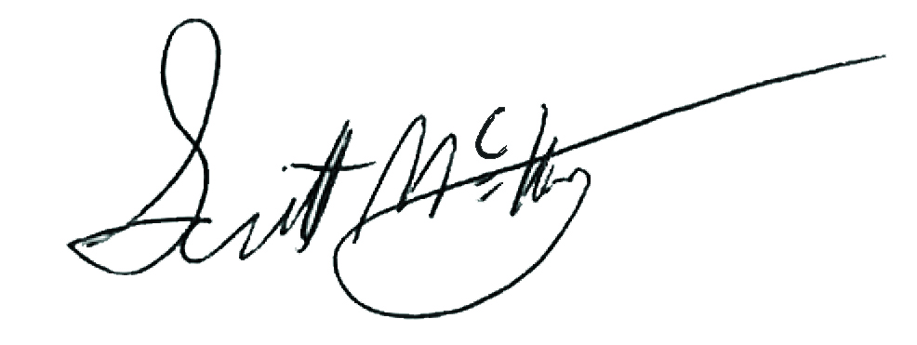 |  | 1/30/2018
Department Coordinator | School/College Dean | Institutional Approval Signature |  | Date

Section 1. Existing Course Title and Description

Prefix & No. | Course Title | Credits
DAD 322 | Audio Production II: Multi-Track Environments | 3

Effective Date: | Click here to enter a date.

This course is a (Place an “X” in the appropriate box):
☒ | Unique Course (see section 2) |  | ☐ | Common Course (see section 3)

Section 2. Unique Courses: Requested Minor Modifications
Place an “X” in the appropriate boxes.

 |  | Current |  | New
☐ | Prefix change |  | to

☐ | Course Number change |  | to
NOTE: You may only change a unique course number to a number not currently used in “active” status at another university. Consult the system database in Colleague or the Course Inventory Report.

☐ | Credit hours |  | to

☒ | Course pre-requisites | DAD 222 | to | MUS 204 and  DAD 222

☐ | Course co-requisites |  | to

☐ | Registration restriction |  | to

☐ | Enrollment limitation |  | to

☐ | Repeatable for additional credit |  | to

☐ | Grading option |  | to

☐ | Course title change
NOTE: The Enrollment Services Center assigns the short, abbreviated course title that appears on transcripts. The short title is limited to 30 characters (including spaces); meaningful but concise titles are encouraged due to space limitations in Colleague.

☐ | Cross-listing and equating with

☐ | Dual-listing at 400/500 level

☒ | Course description (that does not change course content). Complete table below:

Existing description:
Builds upon Audio Production I. Course focus is on multi-track recording, production, mixing, and editing in professional software applications. Other topics taught include mixing console management, signal processing, ear training, advanced audio for video editing, and live sound production techniques.

New description:
Builds upon Audio Production I. Course focus is on multi-track recording, production, mixing, and editing in professional software applications, Pro Tools. Other topics taught include mixing console management, signal processing, effects, plug-ins, and critical listening practices.
Note: Course descriptions are short, concise summaries that typically do not exceed 75 words. DO: Address the content of the course and write descriptions using active verbs (e.g., explore, learn, develop, etc.). DO NOT: Repeat the title of the course, layout the syllabus, use pronouns such as “we” and “you,” or rely on specialized jargon, vague phrases, or clichés.

☐ | Add course in x9x series
 | CIP Code:

 | New to this university? |  | ☐ | Yes | ☐ | No
 | Will this university’s sections of the course be limited to S/U (pass/fail)?
 |  |  | ☐ | Yes | ☐ | No

☐ | Delete Course (effective date): | Click here to enter a date.

Justification for changes indicated in Section 2:
Efforts to increase interdisciplinary collaboration in the Digital Arts and Design program, lead to an enrichment and specification of DAD 222 Audio Production I: Foundations for the Digital Sound Design Specialization. This allows room for a deepening and higher level of study within the scope of DAD 322 Audio Production II: Multi-Track Environments as well. This new course description reflects this enhanced curriculum, which is now Digital Sound Design specific.

Section 3. Common Courses: Requested Minor Modifications
Place an “X” in the appropriate boxes.

 |  | Current |  | New
☐ | Credit hours (within variable limits) |  | to

☐ | University specific co-requisites |  | to

☐ | Cross-listing and equating with

☐ | Dual-listing at 400/500 level

☐ |  | Add course in x9x series
 |  | CIP Code:
 | New to this university? |  |  | ☐ |  | Yes | ☐ | No
 | Will this university’s sections of the course be limited to S/U (pass/fail)?

 | ☐ | Yes | ☐ | No

☐ | x9x grading method |  | to

Justification for changes indicated in Section 3:

Section 4. Department and Course Codes (Completed by University Academic Affairs)

4.1. University department code:

4.2. Change university department code to:

