SOUTH DAKOTA BOARD OF REGENTS
ACADEMIC AFFAIRS FORMS
Existing Courses Minor Modification

Use this form to request minor modifications of existing unique and common courses. Consult the system database through Colleague or the Course Inventory Report for information about existing courses before submitting this form. If the course revision is for an approved General Education course, please see the Revision to General Education Requirements Form.

DSU |  | College of Arts & Sciences |  | Sandra Champion and Peter Kim |  | 11/22/2017
Institution |  | Division/Department |  | Originator |  | Date
Ryan English |  | A&S / Benjamin Jones |  | 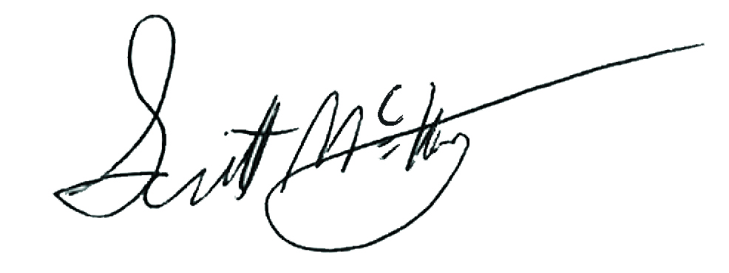 |  | Click here to enter a date.
Department Chair/Coord |  | School/College Dean |  | Institutional Approval Signature |  | Date

Section 1. Existing Course Title and Description

Prefix & No. | Course Title | Credits
DAD 222 | Audio Production I: Foundations | 3

Effective Date: | Click here to enter a date.

This course is a (Place an “X” in the appropriate box):
☒ | Unique Course (see section 2) |  | ☐ | Common Course (see section 3)

Section 2. Unique Courses: Requested Minor Modifications
Place an “X” in the appropriate boxes.

 |  | Current |  | New
☐ | Prefix change |  | to

☐ | Course Number change |  | to
NOTE: You may only change a unique course number to a number not currently used in “active” status at another university. Consult the system database in Colleague or the Course Inventory Report.

☐ | Credit hours |  | to

☐ | Course pre-requisites |  | to

☐ | Course co-requisites |  | to

☐ | Registration restriction |  | to

☐ | Enrollment limitation |  | to

☐ | Repeatable for additional credit |  | to

☐ | Grading option |  | to

☐ | Course title change

☐ | Cross-listing and equating with

☐ | Dual-listing at 400/500 level

☒ | Course description (that does not change course content). Complete table below:

Existing description:
A foundation study of audio recording techniques and digital audio editing. Explores the audio chain from input to processing and output. Topics including microphones, connection types, basic mixing, digital manipulation, and output file formats. Also includes basic MIDI production applications and editing sound for video.

New description:
A foundation study of audio recording techniques and digital audio editing. Students learn signal chain of professional audio mixers and DAWs by dissecting each component and rerouting it within the chain itself. Topics including microphones, connection types, EQ, dynamic processors, basic mixing, digital manipulation, and output file formats.

☐ | Add course in x9x series
 | CIP Code:

New to this university? |  | ☐ | Yes | ☐ | No

Will this university’s sections of the course be limited to S/U (pass/fail)?

 | ☐ | Yes | ☐ | No

☐ | Delete Course (effective date): | Click here to enter a date.

Justification for changes indicated in Section 2:
Efforts to increase interdisciplinary collaboration in the Digital Arts and Design Program, lead to this course’s removal from the CORE course offerings, to allow room for the addition of MUS 204 as the introductory collaborative course for the Major. This facilitated the enrichment of the DAD 222 – Audio Production I: Foundations course, making it a true foundations course with deeper and more meaningful scope for students in the Digital Sound Design Specialization. This new course description reflects this enhanced curriculum, which is now Digital Sound Design specific.

Section 3. Common Courses: Requested Minor Modifications
Place an “X” in the appropriate boxes.

 |  | Current |  | New
☐ | Credit hours (within variable limits) |  | to

☐ | University specific co-requisites |  | to

☐ | Cross-listing and equating with

☐ | Dual-listing at 400/500 level

☐ |  | Add course in x9x series
 |  | CIP Code:
 | New to this university? |  |  | ☐ |  | Yes | ☐ | No
 | Will this university’s sections of the course be limited to S/U (pass/fail)?
 |  |  |  | ☐ |  | Yes | ☐ | No

☐ | x9x grading method |  | to

Justification for changes indicated in Section 3:

Section 4. Department and Course Codes (Completed by University Academic Affairs)

4.1. University department code:

4.2. Change university department code to:

