SOUTH DAKOTA BOARD OF REGENTS
ACADEMIC AFFAIRS FORMS
Existing Courses Minor Modification

Use this form to request minor modifications of existing unique and common courses. Consult the system database through Colleague or the Course Inventory Report for information about existing courses before submitting this form. If the course revision is for an approved General Education course, please see the Revision to General Education Requirements Form.

DSU |  | College of A&S |  | Thomas Jones |  | 11/27/2017
Institution |  | Division/Department |  | Originator |  | Date
Ryan English |  | A&S / Benjamin Jones |  | 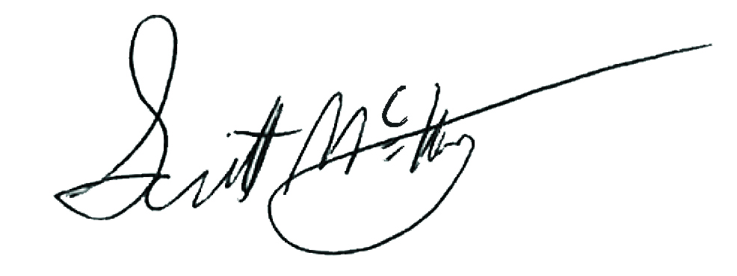 |  | Click here to enter a date.
Department Chair/Coord |  | School/College Dean |  | Institutional Approval Signature |  | Date

Section 1. Existing Course Title and Description

Prefix & No. | Course Title | Credits
ARTD 436 | Digital Photography II | 3

Effective Date: | Click here to enter a date.

This course is a (Place an “X” in the appropriate box):
☒ | Unique Course (see section 2) |  | ☐ | Common Course (see section 3)

Section 2. Unique Courses: Requested Minor Modifications
Place an “X” in the appropriate boxes.

 |  | Current |  | New
☐ | Prefix change |  | to

☒ | Course Number change | ARTD 436 | to | ARTD 380
NOTE: You may only change a unique course number to a number not currently used in “active” status at another university. Consult the system database in Colleague or the Course Inventory Report.

☐ | Credit hours |  | to

☐ | Course pre-requisites |  | to

☐ | Course co-requisites |  | to

☐ | Registration restriction |  | to

☐ | Enrollment limitation |  | to

☐ | Repeatable for additional credit |  | to

☐ | Grading option |  | to

☐ | Course title change
NOTE: The Enrollment Services Center assigns the short, abbreviated course title that appears on transcripts. The short title is limited to 30 characters (including spaces); meaningful but concise titles are encouraged due to space limitations in Colleague.

☐ | Cross-listing and equating with

☐ | Dual-listing at 400/500 level

☐ | Course description (that does not change course content). Complete table below:

Existing description:

New description:
Note: Course descriptions are short, concise summaries that typically do not exceed 75 words. DO: Address the content of the course and write descriptions using active verbs (e.g., explore, learn, develop, etc.). DO NOT: Repeat the title of the course, layout the syllabus, use pronouns such as “we” and “you,” or rely on specialized jargon, vague phrases, or clichés.

☐ | Add course in x9x series
 | CIP Code:

New CIP Code for this university? |  | ☐ | Yes | ☐ | No

Will this university’s sections of the course be limited to S/U (pass/fail)?

 | ☐ | Yes | ☐ | No

☐ | Delete Course (effective date): | Click here to enter a date.

Justification for changes indicated in Section 2:
This change in course numbering more concisely reflects the advanced course content that is constructed upon the lower division work. It will also create a sequential numbering system for the digital photography courses.

Section 3. Common Courses: Requested Minor Modifications
Place an “X” in the appropriate boxes.

 |  | Current |  | New
☐ | Credit hours (within variable limits) |  | to

☐ | University specific co-requisites |  | to

☐ | Cross-listing and equating with

☐ | Dual-listing at 400/500 level

☐ | Add course in x9x series
 | CIP Code:

New CIP Code for this university? | ☐ | Yes | ☐ | No

Will this university’s sections of the course be limited to S/U (pass/fail)?

 | ☐ | Yes | ☐ | No

☐ | x9x grading method |  | to

Justification for changes indicated in Section 3:

Section 4. Department and Course Codes (Completed by University Academic Affairs)

- University department code:

- Change university department code to:

